**Straw testing and analysis report**

**Professor Farny**

**Section : B1**

**Group member:**

**Chutian Xie**

**Sihang Zhou**

**Yicheng Pan**

Content

Introduction

Procedure

Analysis

Data

Result

Discussion

1. Introduction

The first step of the Truss Design Project is the Materials analysis which includes the measurement and analysis of the data on the physical properties of soda straws. It is crucial to build a truss which only meets its physical specification so that no failure will occur. Also, one of the main subjects is to find the liner relationship between the length of the straw and its maximum load.

1. Procedure

• Three straw lengths will be needed: 10cm, 12cm, 15cm. First of all, we select 15 straight straws and cut every 5 of them into 10cm, 12cm, and 15cm. Then we make all the straws double-pinned at both ends with the first pin 5 mm from the end and the second 5 mm in from that. And all pins are perpendicular to the straw axis and parallel to each other.

• Put the straw into the tester vertically and make sure the straw is supported only by the pins sitting squarely in the slots.

• Set the hinged lever arm horizontal and perpendicular to the straw in all directions when the straws are tested.

• Before testing, measure the dimensions and the number of every tester which will be used. First, place the initial mass (400g) in the bucket and wait for 60 seconds. If no buckling occurs, increase the mass by 50g and record the increment and wait for another 60 seconds. Repeat until the straw is near buckling. Then reduce the increments into 20g and repeat the steps until the buckling occurs. Finally, record the last mass successfully holds for 60 seconds.

1. Analysis

FBD:

                           F 19.7cm W=mg

14~14.4 cm

A

16.5cm

apparatus weight =220~221g

F

According to the FBD, the total moment at point A is zero. F is the load that the straw holds which is what we try to find out.

M_A= -(distance to app)( apparatus weight) – (distance to added weight)(W)+(F)( distance to straw)= 0

For Straw length: 10 cm. Apparatus 4

Average maximum load= 16.76N

M_A = -(0.143m)(0.221kg*9.8N/kg) - (0.165 m)(W) + (0.197 m)(F) = 0

F= (0.42666+0.165W)/0.197

F=16.2N

For Straw length: 12 cm. Apparatus 6

Average maximum load= 11.33N

M_A = -(0.14m)(0.22kg*9.8N/kg) - (0.166 m)(W) + (0.197 m)(F) = 0

F= (0.30184+0.166W)/0.197

F=11.079N

For Straw length: 15 cm. Apparatus 9

Average maximum load= 6.10N

MA = -(0.144m)(0.22kg*9.8N/kg) - (0.165 m)(W) + (0.197 m)(F) = 0

F= (0.310464+0.165W)/0.197

F=6.68N

**Curve Fitting**

Matlab code:

x = [10 12 15];

y = [16.2 11.08 6.68];

E = std(y)*ones(size(x));

errorbar(x,y,E,'k') ;

hold on

p = polyfit(x,y,1);

yfit = polyval(p,x);

plot(x,y,'b*',x,yfit,'r')

title('Length vs. Load')

legend('error bar','Experiment','Linerfit')

xlabel('Length of the straw(cm)')

ylabel('Straw maximum load(N)')

axis([9 16 5 20])

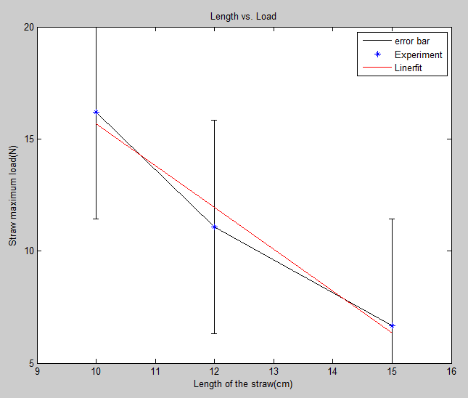

The liner relation between the length and the max load of the straw is:

Load (N) = -1.8695*Length(cm)+34.3768

1. Data

|  |  |  |  |
| --- | --- | --- | --- |
| Straw length: 10 cm Apparatus 4 | | | |
| Trial # | mass load | mass wight | load on straw |
| Trial 1 | 1750g | 17.15N | 16.5N |
| Trial 2 | 1740g | 17.05N | 16.44N |
| Trial 3 | 1600g | 15.68N | 15.29N |
| Trial 4 | 1720g | 16.86N | 16.28N |
| Trial 5 | 1740g | 17.05N | 16.44N |
| Average | 1710g | 16.76N | 16.2N |
| Std.dev. | 48.166g | 0.547N | 0.5097N |
| Mean | 1750g | 17.15N | 16.5N |

|  |  |  |  |
| --- | --- | --- | --- |
| Straw length: 12 cm Apparatus 6 | | | |
| Trial # | mass load | mass wight | load on straw |
| Trial 1 | 1200g | 11.76N | 11.43N |
| Trial 2 | 1150g | 11.27N | 11.02N |
| Trial 3 | 1100g | 10.78N | 10.61N |
| Trial 4 | 1150g | 11.27N | 11.02N |
| Trial 5 | 1180g | 11.56N | 11.26N |
| Average | 1156g | 11.33N | 11.079N |
| Std.dev | 33.823g | 0.331N | 0.31N |
| Mean | 1150g | 11.27N | 11.02N |

|  |  |  |  |
| --- | --- | --- | --- |
| Straw length: 15 cm Apparatus 9 | | | |
| Trial # | mass load | mass wight | load on straw |
| Trial 1 | 590g | 5.78N | 6.41N |
| Trial 2 | 610g | 5.98N | 6.58N |
| Trial 3 | 630g | 6.17N | 6.74N |
| Trial 4 | 680g | 6.66N | 7.15N |
| Trial 5 | 600g | 5.88N | 6.5N |
| Average | 622g | 6.10N | 6.68N |
| Std.dev. | 31.87g | 0.362N | 0.29N |
| Mean | 610g | 5.98N | 6.58N |

1. Result

Please see the plot in the data analysis.

1. Discussion

Possible error :

1. There might be some length loss when the straws are cut.
2. The straws in the tester are not perfectly vertical.
3. The hinged lever arm is not horizontal and perpendicular to the straw.
4. Not all pins are perpendicular to the straw axis and parallel to each other.